1. Signup With Github <https://github.com/>
2. Login

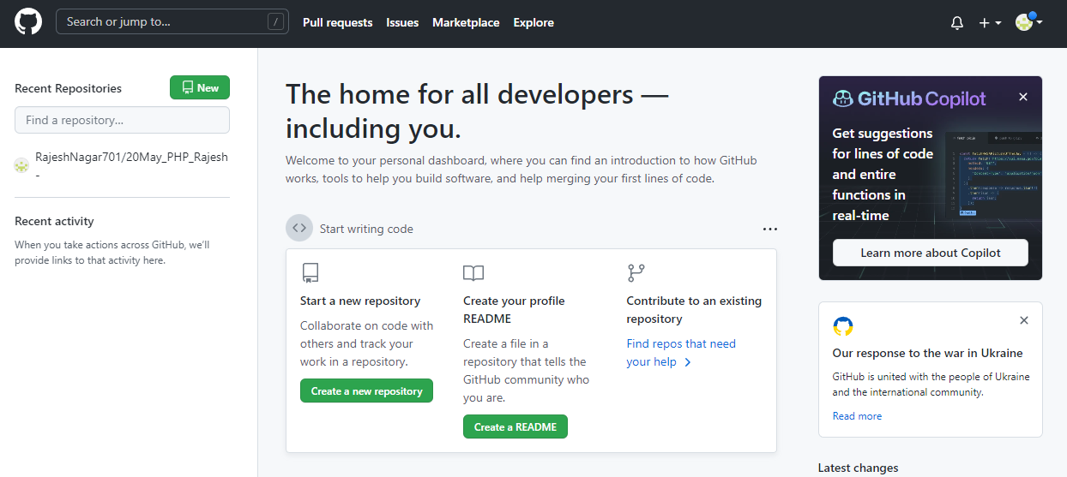

1. Download git bash <https://git-scm.com/downloads>

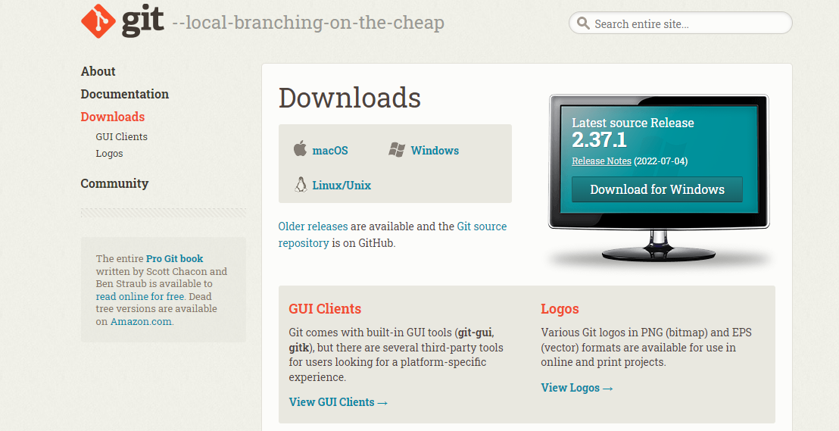

1. Create Repository

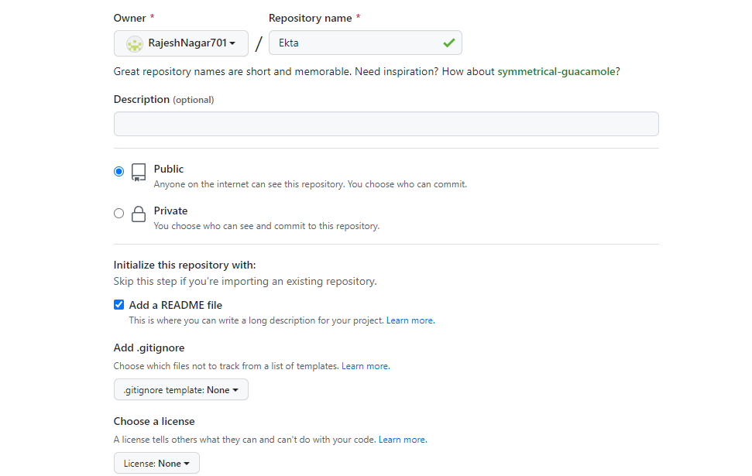

1. Upload data on Repository

Open folder which you want to upload

Left click & open with

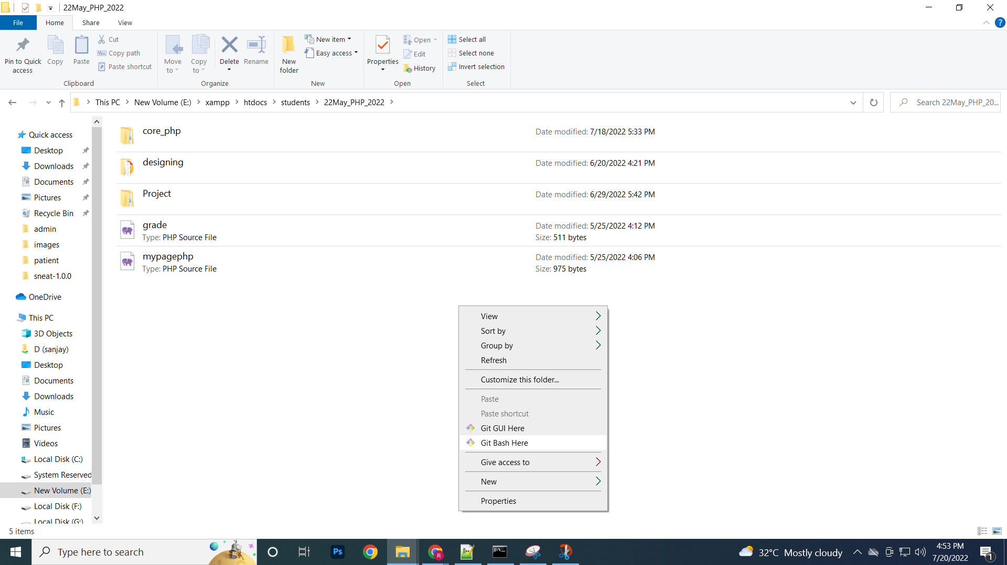

1)Git init

2)Git add .

3)git commit -m "first commit"

If error then do as per error like ..

git config --global --add safe.directory E:/xampp/htdocs/students/02May_Frontend_2022

Again enter …

=>git config --global user.email “[rajeshnagar.tops@gmail.com](mailto:rajeshnagar.tops@gmail.com)”

=>git config --global user.name “RajNagar701”

git remote add origin <https://github.com/RajeshNagar701/20May_PHP_Rajesh.git>

git push origin master

**If any changes then again save**

git add .

git status

git commit -m 'updated'

git push origin master

If want to open & work online server open vs code

Open vs code

Terminal => new Terminal

git add .

git status

git commit -m 'changed'

git push origin master